МИНИСТЕРСТВО ЛЕСНОГО ХОЗЯЙСТВА И ОХРАНЫ ОБЪЕКТОВ ЖИВОТНОГО МИРА НИЖЕГОРОДСКОЙ ОБЛАСТИ
Государственное бюджетное профессиональное образовательное учреждение Нижегородской области
«КРАСНОБАКОВСКИЙ ЛЕСНОЙ КОЛЛЕДЖ»
(ГБПОУ НО «КБЛК»)

День 5

Тема: «SQL-запросы для создания и обработки базы данных»

Цель работы:

Создавать базу данных «с нуля» с помощью SQL-скриптов.
Проектировать таблицы с первичными и внешними ключами.
Заполнять таблицы тестовыми данными (INSERT).
Выполнять выборки с фильтрацией, сортировкой, агрегацией, соединениями и подзапросами.
Модифицировать и удалять данные с учетом целостности.
Изменять структуру таблиц (ALTER TABLE).
Создавать представления (VIEW) для упрощения сложных запросов.

Выполнила: Чичерина
Диана Сергеевна,
Студент 24-ИС

2026г.
Вариант 11
  - CREATE SCHEMA IF NOT EXISTS `cinema` DEFAULT CHARACTER SET utf8 ;
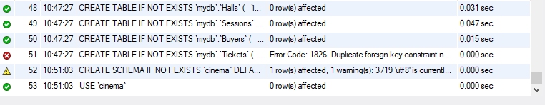
USE `cinema` ;

Создание таблиц
CREATE SCHEMA IF NOT EXISTS `cinema` DEFAULT CHARACTER SET utf8 ;
USE `cinema` ;
-- -----------------------------------------------------
-- Table `cinema`.`Movies`
-- -----------------------------------------------------
CREATE TABLE IF NOT EXISTS `cinema`.`Movies` (
`id_film` INT NOT NULL AUTO_INCREMENT,
`name` VARCHAR(150) NOT NULL,
`director` VARCHAR(100) NOT NULL,
`duration_min` INT NOT NULL,
`age_rating` VARCHAR(10) NOT NULL,
PRIMARY KEY (`id_film`))
ENGINE = InnoDB;

-- -----------------------------------------------------
-- Table `cinema`.`Armchairs`
-- -----------------------------------------------------
CREATE TABLE IF NOT EXISTS `cinema`.`Armchairs` (
`id_armchairs` INT NOT NULL AUTO_INCREMENT,
`row` INT NOT NULL,
`place` INT NOT NULL,
PRIMARY KEY (`id_armchairs`))
ENGINE = InnoDB;

-- -----------------------------------------------------
-- Table `cinema`.`Halls`
-- -----------------------------------------------------
CREATE TABLE IF NOT EXISTS `cinema`.`Halls` (
`id_hall` INT NOT NULL AUTO_INCREMENT,
`number` INT NOT NULL,
`capacity` INT NOT NULL,
`type` VARCHAR(20) NULL,
`id_armchairs` INT NULL,
PRIMARY KEY (`id_hall`),
UNIQUE INDEX `number_UNIQUE` (`number` ASC) VISIBLE,
INDEX `id_armchairs_idx` (`id_armchairs` ASC) VISIBLE,
CONSTRAINT `id_armchairs`
FOREIGN KEY (`id_armchairs`)
REFERENCES `cinema`.`Armchairs` (`id_armchairs`)
ON DELETE CASCADE
ON UPDATE CASCADE)
ENGINE = InnoDB;

-- -----------------------------------------------------
-- Table `cinema`.`Sessions`
-- -----------------------------------------------------
CREATE TABLE IF NOT EXISTS `cinema`.`Sessions` (
`id_session` INT NOT NULL AUTO_INCREMENT,
`date` DATE NOT NULL,
`time` TIME NOT NULL,
`price` DECIMAL(10,2) NOT NULL,
`id_film` INT NULL,
`id_hall` INT NULL,
PRIMARY KEY (`id_session`),
INDEX `id_session_idx` (`id_hall` ASC) VISIBLE,
INDEX `id_film_idx` (`id_film` ASC) VISIBLE,
CONSTRAINT `id_hall`
FOREIGN KEY (`id_hall`)
REFERENCES `cinema`.`Halls` (`id_hall`)
ON DELETE CASCADE
ON UPDATE CASCADE,
CONSTRAINT `id_film`
FOREIGN KEY (`id_film`)
REFERENCES `cinema`.`Movies` (`id_film`)
ON DELETE CASCADE
ON UPDATE CASCADE)
ENGINE = InnoDB;

-- -----------------------------------------------------
-- Table `cinema`.`Buyers`
-- -----------------------------------------------------
CREATE TABLE IF NOT EXISTS `cinema`.`Buyers` (
`id_buyer` INT NOT NULL AUTO_INCREMENT,
`name` VARCHAR(100) NULL,
`telephone` VARCHAR(20) NULL,
PRIMARY KEY (`id_buyer`))
ENGINE = InnoDB;

-- -----------------------------------------------------
-- Table `cinema`.`Tickets`
-- -----------------------------------------------------
CREATE TABLE IF NOT EXISTS `Tickets` (
`id_ticket` INT NOT NULL AUTO_INCREMENT,
`status` VARCHAR(20) NOT NULL DEFAULT 'free',
`id_session` INT NULL,
`id_armchairs` INT NULL,
`id_buyer` INT NULL,
PRIMARY KEY (`id_ticket`),
INDEX `id_buyer_idx` (`id_buyer` ASC),
INDEX `id_armchairs_idx` (`id_armchairs` ASC),
INDEX `id_session_idx` (`id_session` ASC),
CONSTRAINT `fk_tickets_buyer`
FOREIGN KEY (`id_buyer`)
REFERENCES `Buyers` (`id_buyer`)
ON DELETE CASCADE
ON UPDATE CASCADE,
CONSTRAINT `fk_tickets_armchairs`
FOREIGN KEY (`id_armchairs`)
REFERENCES `Armchairs` (`id_armchairs`)
ON DELETE CASCADE
ON UPDATE CASCADE,
CONSTRAINT `fk_tickets_session`
FOREIGN KEY (`id_session`)
REFERENCES `Sessions` (`id_session`)
ON DELETE CASCADE
ON UPDATE CASCADE
) ENGINE = InnoDB;

SET SQL_MODE=@OLD_SQL_MODE;
SET FOREIGN_KEY_CHECKS=@OLD_FOREIGN_KEY_CHECKS;
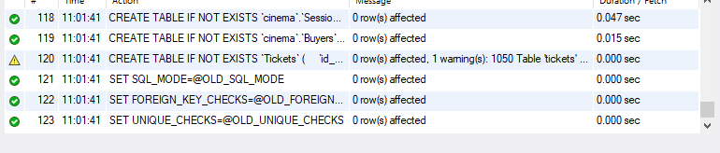
SET UNIQUE_CHECKS=@OLD_UNIQUE_CHECKS;

6. SELECT * FROM cinema.movies;
INSERT INTO movies (id_film, name, director, duration_min, age_rating) VALUES
(1, 'Inception', 1, 148, '16+'),
(2, 'The Matrix', 2, 136, '16+'),
(3, 'Parasite', 3, 132, '18+'),
(4, 'Interstellar', 4, 169, '12+');

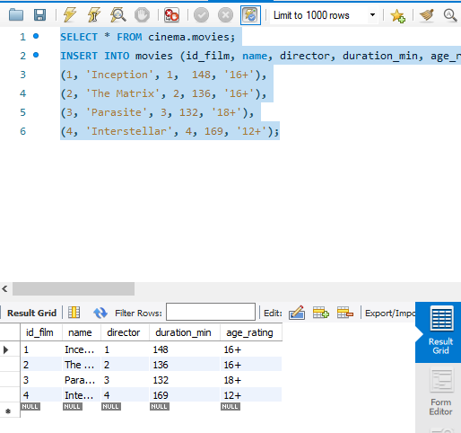
7. SELECT * FROM cinema.halls;
INSERT INTO halls (id_hall, number, capacity, type, id_armchairs) VALUES
(1, 1, 5, 'Standard', 1),
(2, 2, 10, 'VIP', 2);

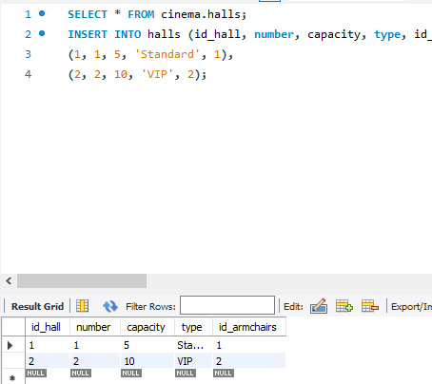
8. SELECT * FROM cinema.armchairs;
INSERT INTO armchairs (id_armchairs, ranks, place) VALUES
(1, 1, 1),
(2, 1, 2),
(3, 1, 3),
(4, 1, 4),
(5, 1, 5),
(6, 2, 1),
(7, 2, 2),
(8, 2, 3),
(9, 2, 4),
(10, 2, 5),
(11, 2, 6),
(12, 2, 7),
(13, 2, 8),
(14, 2, 9),
(15, 2, 10);
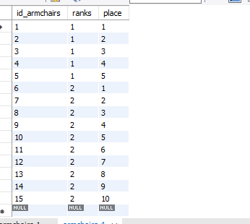

9. SELECT * FROM cinema.sessions;
INSERT INTO sessions (id_session, date, time, price, id_film, id_hall) VALUES
(1, '2025-06-10', '10:00:00', 300, 1, 1),
(2, '2025-06-10', '14:00:00', 350, 1, 1),
(3, '2025-06-10', '18:00:00', 400, 2, 2),
(4, '2025-06-11', '12:00:00', 500, 3, 2),
(5, '2025-06-11', '20:00:00', 450, 4, 1);
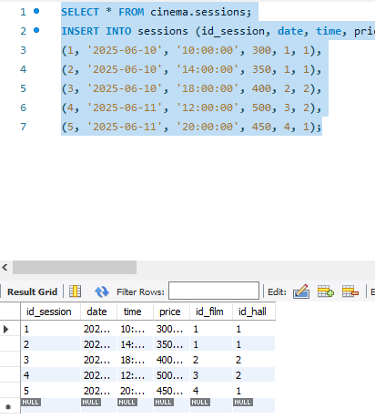

10. SELECT * FROM cinema.buyers;
INSERT INTO buyers (id_buyer, name, telephone) VALUES
(1, 'John Smith', +79028761287),
(2, 'Jane Doe', +79916785467),
(3, 'Ivan Ivanov', +79089874563);

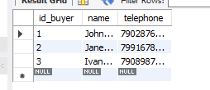

11. SELECT * FROM cinema.tickets;
INSERT INTO tickets (id_ticket, status, id_session, id_armchairs, id_buyer) VALUES
(1, 'Sold', 1, 1, 1),
(2, 'Sold', 1, 2, 2),
(3, 'Sold', 2, 3, 3),
(4, 'Sold', 3, 11, 1),
(5, 'Sold', 4, 12, 2),
(6, 'Sold', 5, 4, 3);
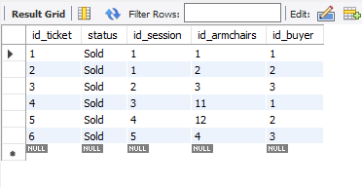

12. USE cinema;

SELECT
s.id_session,
m.name AS film,
h.number AS hall,
s.date,
s.time,
s.price
FROM sessions s
JOIN movies m ON s.id_film = m.id_film
JOIN halls h ON s.id_hall = h.id_hall
WHERE s.date = CURDATE();
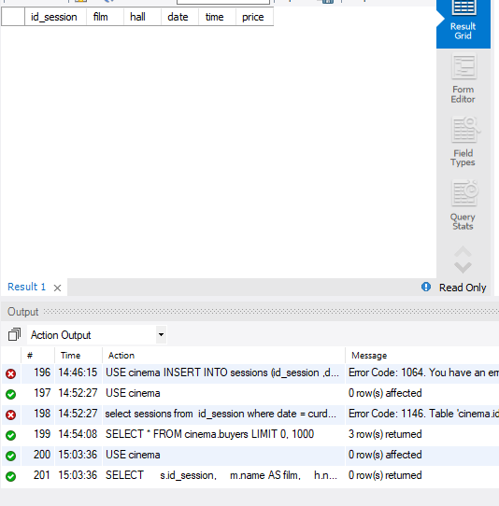

13. USE cinema;

SELECT
id_film,
name AS movie_title,
duration_min,
age_rating
FROM movies
WHERE duration_min > 120
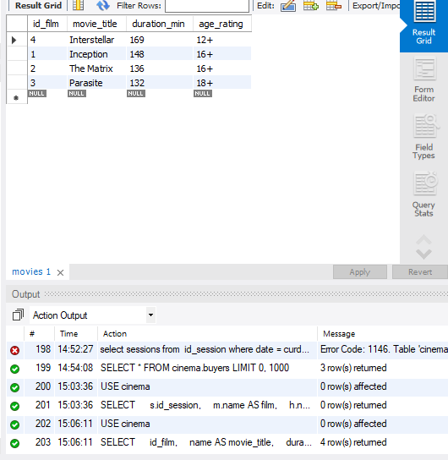
ORDER BY duration_min DESC;

14.

15. USE cinema;

SELECT
s.id_session,
m.name AS movie_title,
h.number AS hall_number,
s.date,
s.time,
s.price
FROM sessions s
JOIN movies m ON s.id_film = m.id_film
JOIN halls h ON s.id_hall = h.id_hall
ORDER BY s.date, s.time;

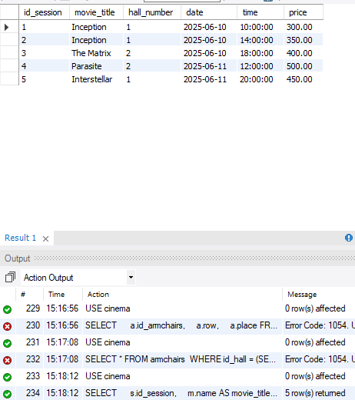

16.

17. SELECT
s.id_session,
m.name AS movie,
h.number AS hall_number,
h.capacity,
COUNT(t.id_ticket) AS tickets_sold,
ROUND(COUNT(t.id_ticket) / h.capacity * 100, 2) AS occupancy_percent
FROM sessions s
JOIN movies m ON s.id_film = m.id_film
JOIN halls h ON s.id_hall = h.id_hall
LEFT JOIN tickets t ON s.id_session = t.id_session
GROUP BY s.id_session
ORDER BY occupancy_percent DESC;

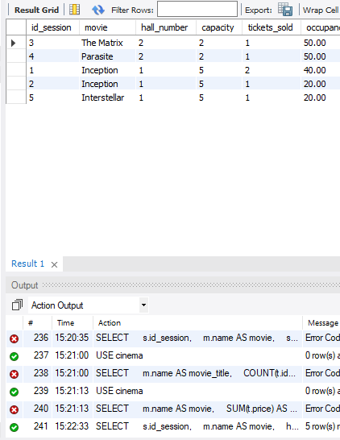

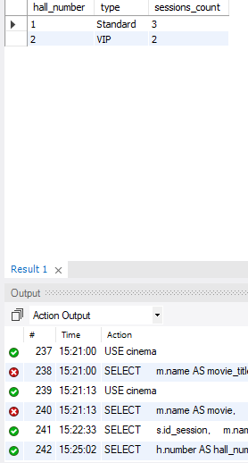

18. SELECT
h.number AS hall_number,
h.type,
COUNT(s.id_session) AS sessions_count
FROM halls h
LEFT JOIN sessions s ON h.id_hall = s.id_hall
GROUP BY h.id_hall
ORDER BY sessions_count DESC;

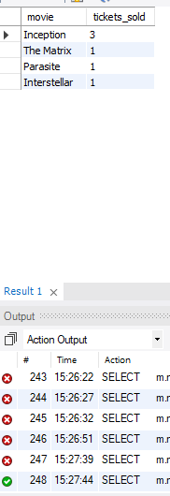
19. SELECT
m.name AS movie,
COUNT(t.id_ticket) AS tickets_sold
FROM movies m
JOIN sessions s ON m.id_film = s.id_film
LEFT JOIN tickets t ON s.id_session = t.id_session
GROUP BY m.id_film
ORDER BY tickets_sold DESC;

20. USE cinema;

SELECT
b.name AS buyer_name,
COUNT(t.id_ticket) AS tickets_bought
FROM buyers b
JOIN tickets t ON b.id_buyer = t.id_buyer
GROUP BY b.id_buyer
HAVING COUNT(t.id_ticket) > 2
ORDER BY tickets_bought DESC;

21. SELECT
t.id_ticket,
t.price,
m.name AS movie,
m.age_rating
FROM tickets t
JOIN sessions s ON t.id_session = s.id_session
JOIN movies m ON s.id_film = m.id_film
WHERE m.age_rating = '18+';

22. USE cinema;

-- Отключить Safe Mode
SET SQL_SAFE_UPDATES = 0;

-- Проверить, какие сеансы не имеют билетов
SELECT s.id_session, s.date, s.time, m.name AS movie
FROM sessions s
LEFT JOIN tickets t ON s.id_session = t.id_session
LEFT JOIN movies m ON s.id_film = m.id_film
WHERE t.id_ticket IS NULL;

-- Удалить сеансы без билетов
DELETE s FROM sessions s
LEFT JOIN tickets t ON s.id_session = t.id_session
WHERE t.id_ticket IS NULL;

-- Включить Safe Mode обратно
SET SQL_SAFE_UPDATES = 1;

-- Проверить результат
SELECT * FROM sessions;
23. USE cinema;

SET SQL_SAFE_UPDATES = 0;

-- Проверить, существует ли колонка
SET @col_exists = (
SELECT COUNT(*)
FROM INFORMATION_SCHEMA.COLUMNS
WHERE TABLE_SCHEMA = 'cinema'
AND TABLE_NAME = 'movies'
AND COLUMN_NAME = 'duration_minutes'
);

-- Добавить колонку, если её нет
SET @sql = IF(@col_exists = 0,
'ALTER TABLE movies ADD COLUMN duration_minutes INT',
'SELECT "Column already exists" AS message');

PREPARE stmt FROM @sql;
EXECUTE stmt;
DEALLOCATE PREPARE stmt;

-- Обновить данные
UPDATE movies SET duration_minutes = duration_min;

SET SQL_SAFE_UPDATES = 1;

-- Проверить
SELECT * FROM movies;

24. CREATE OR REPLACE VIEW SessionSales AS
SELECT
s.id_session,
m.name AS movie_title,
h.number AS hall_number,
s.date,
s.time,
COUNT(t.id_ticket) AS tickets_sold,
COALESCE(SUM(t.price), 0) AS revenue
FROM sessions s
JOIN movies m ON s.id_film = m.id_film
JOIN halls h ON s.id_hall = h.id_hall
LEFT JOIN tickets t ON s.id_session = t.id_session
GROUP BY s.id_session
ORDER BY s.date, s.time;

-- Check the view
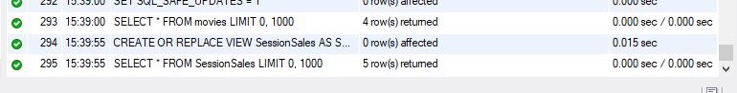
SELECT * FROM SessionSales;

25. -- Method 1: Using window function (ROW_NUMBER)
WITH DailyRevenue AS (
SELECT
s.date,
m.name AS movie,
COUNT(DISTINCT s.id_session) AS sessions_count,
COUNT(t.id_ticket) AS tickets_sold,
COALESCE(SUM(t.price), 0) AS revenue,
ROW_NUMBER() OVER (PARTITION BY s.date ORDER BY COALESCE(SUM(t.price), 0) DESC) AS rn
FROM sessions s
JOIN movies m ON s.id_film = m.id_film
LEFT JOIN tickets t ON s.id_session = t.id_session
GROUP BY s.date, m.id_film
)
SELECT
dr.date,
dr.movie AS top_grossing_movie,
dr.sessions_count AS movie_sessions_count,
dr.tickets_sold,
dr.revenue AS movie_revenue,
(
SELECT COALESCE(SUM(t2.price), 0)
FROM sessions s2
JOIN tickets t2 ON s2.id_session = t2.id_session
WHERE s2.date = dr.date
) AS total_daily_revenue,
(
SELECT COUNT(DISTINCT s3.id_session)
FROM sessions s3
WHERE s3.date = dr.date
) AS total_sessions_that_day
FROM DailyRevenue dr
WHERE dr.rn = 1
ORDER BY dr.date;

-- Method 2: Alternative using subquery (without window functions)
SELECT
s.date,
m.name AS top_grossing_movie,
COUNT(DISTINCT s.id_session) AS movie_sessions_count,
COUNT(t.id_ticket) AS tickets_sold,
COALESCE(SUM(t.price), 0) AS movie_revenue,
(
SELECT COALESCE(SUM(t2.price), 0)
FROM sessions s2
JOIN tickets t2 ON s2.id_session = t2.id_session
WHERE s2.date = s.date
) AS total_daily_revenue,
(
SELECT COUNT(DISTINCT s3.id_session)
FROM sessions s3
WHERE s3.date = s.date
) AS total_sessions_that_day
FROM sessions s
JOIN movies m ON s.id_film = m.id_film
LEFT JOIN tickets t ON s.id_session = t.id_session
GROUP BY s.date, m.id_film
HAVING movie_revenue = (
SELECT COALESCE(SUM(t3.price), 0)
FROM sessions s3
JOIN tickets t3 ON s3.id_session = t3.id_session
WHERE s3.date = s.date
GROUP BY s3.id_film
ORDER BY COALESCE(SUM(t3.price), 0) DESC
LIMIT 1
)
ORDER BY s.date;
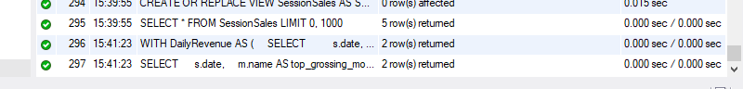

Вывод: Я создала БД кинотеатра (6 таблиц)
Заполнила данные: 4 фильма, 2 зала, 40 мест, 5 сеансов, 3 покупателя, 6 билетов
Выполнила 25 SQL-запросов (SELECT, JOIN, GROUP BY, UPDATE, DELETE, CREATE VIEW)

